Sparks,Steven S.J.
N/A
Memory Corruption vulnerabilities
Understanding modern day memory corruption vulnerabilities

Abstract
Understanding modern day memory corruption vulnerabilities understanding how low level program code runs. Cybersecurity cannot last if it is built on a shoddy foundation of broken C libraries. This of course has been recognized by programmers of C, and they have given us functions that are memory safe. And have deprecated older functions that allow for buffer-overflows. However, some people still use these old deprecated functions because they were popular, or the only way to achieve a certain goal. Here we will explore these memory corruption exploits by programming one, exploiting it.

Research question.
What are Memory corruption vulnerabilities and how do we exploit them?

Subquestions.
- What are memory corruption vulnerabilities?
- How do we prevent memory corruption vulnerabilities?
- How do we exploit memory corruption vulnerabilities?

Methods.
- For question 1, i will explain to the basic concept of the stack and the heap, memory allocation and common data structures. this will encompass library -> Literature study & best & good practices.
- For question 2, i will create a diagram of what is happening, and a POC example of how to prevent an exploit. Encompassing Library study, workshop prototyping, domain modelling.
- For question 3, i will use a code example to demo a real time use of an exploit. Afterwards i will explain how it works. Encompassing showroom test, lab unit test, and workshop decomposition.

What are memory corruption vulnerabilities?

What is memory?
In any computer, memory (otherwise known as RAM) is storage that can be accessed fast and stores run-time information that the operating system or any other software needs to run while the device is on.
It’s called RAM, short for Random Access Memory. Physically, ram is fast storage solution made of transistors to store data.
When a device boots up, it runs the operating system thats installed on the hard drive of a device. The operating system will then assign a chunk of memory to itself, for what it needs to run. This chunk of memory can shrink and grow depending on how much is needed. When memory is assigned, the software responsible is returned an address. Like houses, these addresses can contain information.
If an address were to be empty, the other addresses dont necessarily change. This introduces the pseudo-randomness to memory. To make sure the size of the used memory remains small, we defragment. This removes any gaps between memory segments. Keeping the total used memory better contained.
Running out of memory can happen on a software level, or on a hardware level. On a software level, you will try to store more information than what you are physically allotted to.
if you run out of memory on a hardware level, the device is prone to crash.

Stack & Heap
Diving deeper into memory management, you arrive at the stack and the heap. In short, the stack is accessible to functions in run-time. While the heap is controlled by the programmer.
Stack memory exists for functions creating variables. And only exists as long as the function remains on the stack. Having too many functions on the stack can cause a stack overflow.
The heap is more widely available during a program’s lifetime. Heap memory is not freed after a function ends. And needs to be freed manually. So, any function call that has a program allocate a block of memory during a function’s lifetime is extremely likely to be heap memory.
heap memory is also accessible by other programs and threads running at the same time. This is why the OS handles memory allocation. Otherwise, there is a risk of memory corruption and leaks if the allocation of memory is not handled properly.

Common datastructures
Here i will cover some of the commonly used.
- Arrays
Arrays are predefined blocks of memory, only able to store as much information as they are initialized as. An example of this is an 8 bit integer array of 5 long. This array will reserve 5 blocks of memory of at least 8 bit * 5, resulting in an array that needs 40 bits to be reserved.
(the OS actually cant just reserve only 40 bits. And will in most cases assign the next multiple of 8, which would be 64 bits. Essentially wasting 24 bits. Little optimalisations in your program could mean huge savings!)
- Structs
Structs are custom objects that are user defined, these structs work similarly to arrays, but the types of data stored can be different to just a single type.
- Linked Lists
Unliked arrays, linked lists store information, along with a pointer (or two) to the next element. This is a slightly more costly way of storing information. But in return you maintain a list that can expand and shrink dynamically.
- Stacks & queues
Stacks and queues are built on top of the same principle as linked lists. But are restricted in their use-cases. Stacks are FILO, and queues are FIFO.
- Vectors
A vector is NOT a linked list despite looking like one. A vector is more like an array that can grow. All the storage happens in the same place. There are other reasons that distinct it from a linked list but i wont go into that unless feedback is given.

What are / Types of Memory corruption vulnerabilities
So, after a long preamble of introduction to some basics. These vulnerabilities are exploits of unintended behaviour, errors, or corruption of data. These exploits make use of C / C++’s runtime environment to gain unauthorized control of systems or to break stuff.
Memory corruption vulnerabilities are lumped together under one umbrella. But there are different types of them. I will quickly cover a few common weaknesses from the CWE top 25.
- Buffer overflows
A buffer overflow happens when a program tries to write to memory more than what it had allocated. Essentially writing to a different block of memory. Best case scenario, nothing happens as the memory block adjacent to the block you originally wrote to is empty. Otherwise you have a chance to cause a crash, corrupt the adjacent memory block, or to inject arbitrary code.
- Heap-based buffer overflows
This is a variation of the standard buffer overflow, the where the method is the same, but it applies to the HEAP memory specifically.
- Use-after-free errors
A use after free error happens when you continue to use a pointer after the memory it points to has been deallocated. this can occur if a user follows a different expected path through your software. And your software calls on a variable that has been freed in a step but doesn’t get reinitialised afterwards.
- Improper input validation
The name gives it away; this type of attack is not exclusive to memory vulnerabilities and is a problem on a lot of different sectors of software.
- Integer overflow / wraparound
An integer overflow / wraparound is an arithmetic operation gone wrong. Reaching the end of the size limit of the data type arithmetic is performed on. This type of vulnerability is common in low level environments where these operations are not inherently checked.

How do we prevent memory corruption vulnerabilities
So, we know the common attack vectors. But how to make safer programs that are less likely to fall victim to these kind of attacks?
Common best practices for programming include:
- Replacing vulnerable functions with safer ones
For example, STRCPY is a function in c that copies a string into a pointer from a pointer. This function is well known to cause issues. here is a list of unsafe functions and their replacement. However if you *have* to use the unsafe functions, you need a better solution.
Strcpy | strlcpy/strcpy_s
strcat | strlcat/strcat_s -strtok
sprintf | snprintf
vsprintf | vsnprintf
gets | fgets/gets_s
makepath | makepath_s (MSDN)
_splitpath | _splitpath_s (MSDN)
scanf/sscanf | sscanf_s (MSDN)
snscanf | _snscanf_s (MSDN)
strlen | strnlen_s (MSDN)
[6]
- Initialize pointer variables
Initializing pointers to NULL gives them a default value of nothing. This make it unambigious to the compiler and wont be flagged as a potential error / warning. But it also means it cannot be assigned a different value when the variable is made.

- Using smart pointers instead
Smart pointers are a c++ lang specific. But is a more secure way of creating pointers than doing it manually. From what i understand, smart pointers keep track of who owns a resource and when that ownership should end. For example, unique_ptr is a commonly used pointer, and when the scope it is declared in is exited, the pointer also frees the memory assigned to the pointer.
Ownership of smart pointers can be moved with the std::move() command, taking an existing and not null pointer as a parameter. And can be assigned like a variable using =.

- If possible, use vectors instead of manual allocation.
As explained in commonly used datastructures. Vectors are not susceptible to memory corruption vulnerabilities as they grow and shrink as needed. And are stack allocated, so the user is not involved at all in this process.

Other notable actions you can take are Compiler based solutions and Runtime mechanisms. but these will not be discussed here as to keep the scope focussed.
[7]

Here i have a diagram explaining visually how these exploits typically go, i will also explain what specific mitigation you can implement to prevent it from happening.

How do we exploit memory corruption vulnerabilities
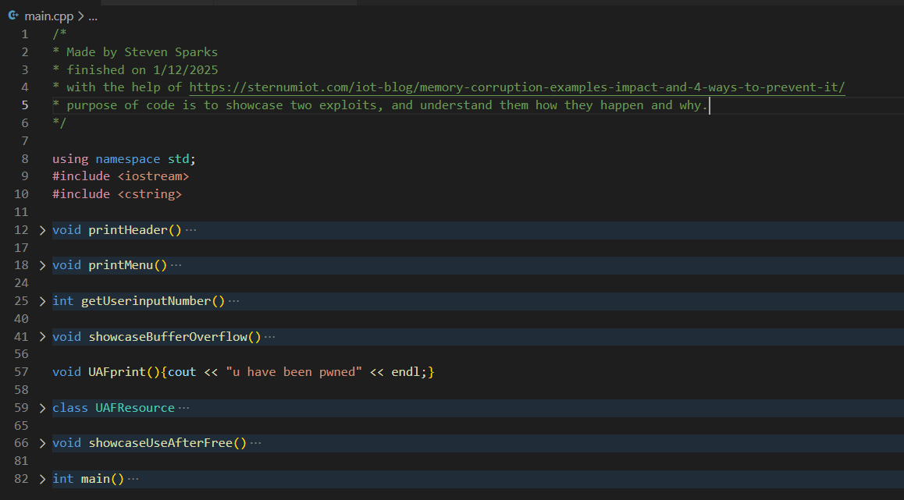

Results.

Conclusion.

References

Sources
- https://sternumiot.com/iot-blog/memory-corruption-examples-impact-and-4-ways-to-prevent-it/
- https://runsafesecurity.com/blog/memory-safety-vulnerabilities/
- https://www.geeksforgeeks.org/dsa/stack-vs-heap-memory-allocation/
- https://jpcairesf.github.io/blog/posts/data-structures-at-low-level/
- https://stackoverflow.com/questions/4700052/are-vector-a-special-case-of-linked-lists
- https://stackoverflow.com/questions/26558197/unsafe-c-functions-and-the-replacement
- https://www.appsecengineer.com/blog/defending-against-memory-corruption-attacks-in-c-based-applications

